

**Customer Analytics and Activation**

**Pilot**

**CAA DsU Technical Documentation Phase – I**

**V 0.1**

**Prepared By: Data Solutions Team**

**Date:** 06/23/2020

Table of Contents

Table of Contents 2

1. Revision Chart 3

2. Approvers 3

Business Approval 3

Project Team Approval 3

3. Introduction 4

4. In scope 4

5. Out of scope 5

6. Assumptions 5

7. Objective and Success criteria 5

8. Risk 6

10. Timelines 7

11. Data Feeds 7

13. Appendix 9

# Revision Chart

This chart contains a version history of the document’s revision

|  |  |  |  |
| --- | --- | --- | --- |
| **Version** | **Primary Author** | **Description of Change** | **Date Completed** |
| V1.0 | Rittika Jindal | Document creation | 06/23/2020 |
|  |  |  |  |
|  |  |  |  |
|  |  |  |  |
|  |  |  |  |

# Reviewers / Approvers

## IT Reviewers

A summary of the required approvals received for this document are captured below.

|  |  |  |  |
| --- | --- | --- | --- |
| **Approver** | **Role** | **Version Approved** | **Approval Date** |
| Christian Snediker-Morscheck | Data Architect |  |  |
| Rittika Jindal | Lead Data Architect |  |  |
| Pradosh Jena | Data Architect |  |  |
| Manish Patel | AVP |  |  |
| Cari Powell | AVP |  |  |
|  |  |  |  |
|  |  |  |  |
|  |  |  |  |
|  |  |  |  |

# 

# Introduction

This document explains the technical design for the foundation lake

# In scope

* 1. Coding Standards
  2. Prototype Framework
  3. Acceptance Criteria-Baseline
  4. Data Model

# Out of scope

* 1. Requirement gathering
  2. Incremental Data load
  3. Phase – II or Implementation Design

1. **Technical details**
   1. High Level Design to load data -

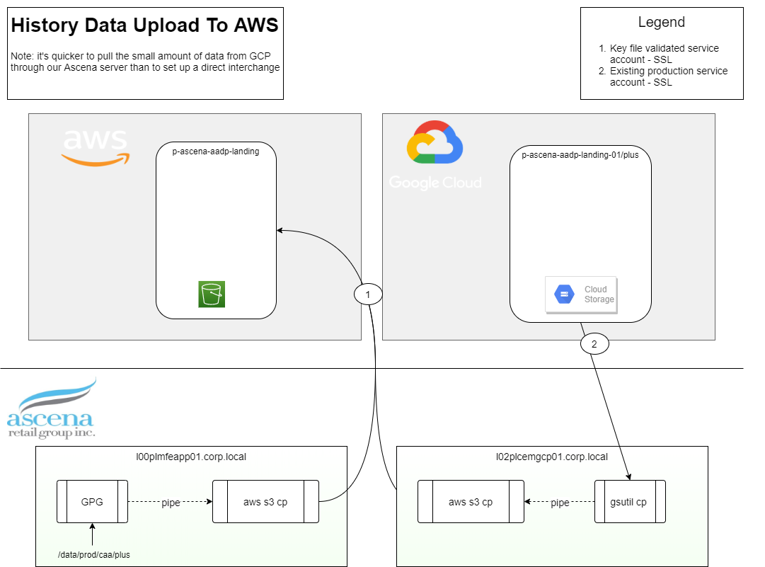

* 1. Prototype Design

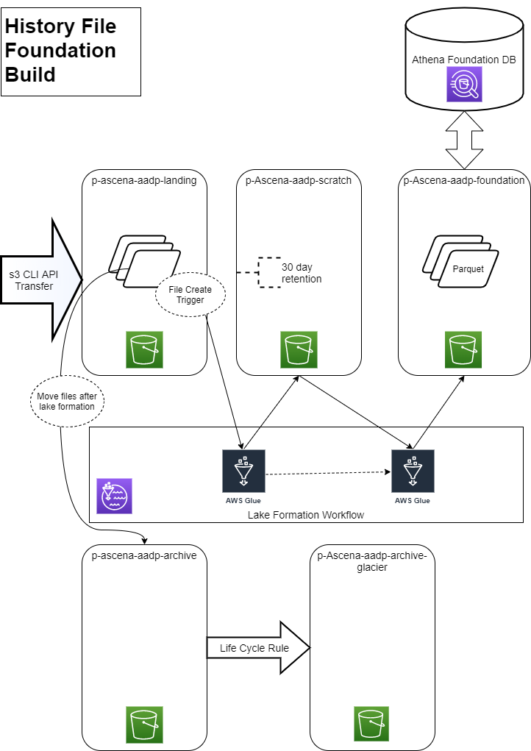

* 1. Source Feeds

<https://ascenaretail.sharepoint.com/:x:/s/sp-asc-CustomerAnalyticsActivationCEMReset/EVSZcUg0rAtNvPXyt7xKFBkBBdkCP6BuBVM9EGJOCx5G3g?e=WPoReU>

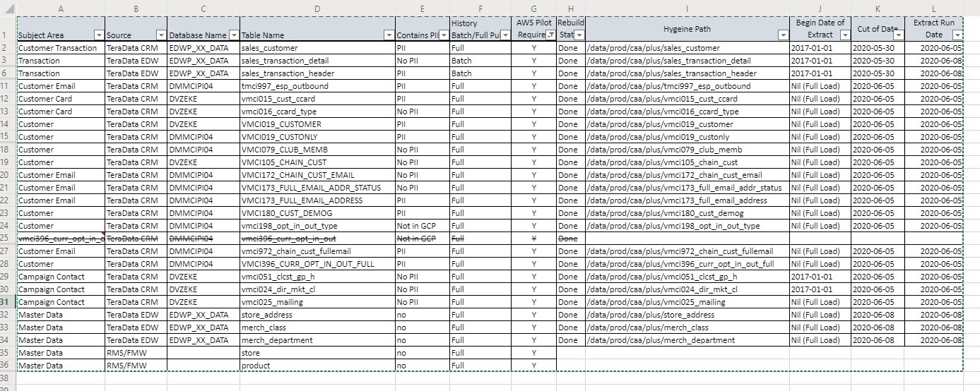

* 1. Prototype Details - focus

Framework standard

* 1. Data model – PDF

# Assumptions

* 1. Adequate help from Amazon SME

1. **Overall Work stream Architecture diagram**

# Timelines

Below estimated timeline based on shifting away from external contractors, to a smaller internal team. Timeline is an estimate till we complete sprint planning for the 3 major phases of the project being configuration, data load and machine learning. This timeline was shared with the Marketing Steer Co on 4/29/2020

